Kingdom Plantae

Division Phaeophyta (brown algae)
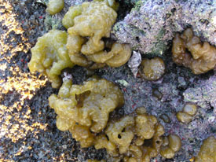
Colpomenia sp., Bubblegum algae

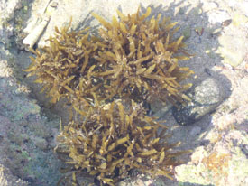
Dictyota sp., Dictyota

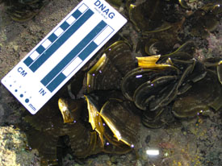
Padina durvillaei, Zone fan algae

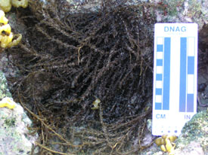
Sargassum sp., Sargassum
http://dtc.pima.edu/%7Enschmidt/gallery/gallery_index.html

Division Chlorophyta (green algae)

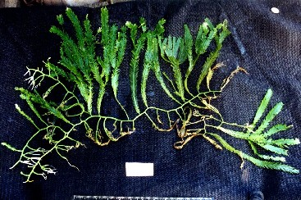
Caulerpa sp., Sea lettuce

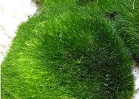
Cladophora sp., Green turf algae
http://www.aquabase.org/algae/view.php3?id=13

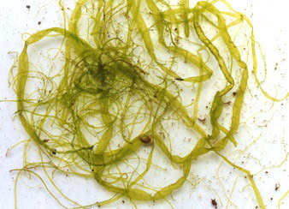
Enteromorpha sp., Green ribbon algae
http://www.btinternet.com/~stephen.durr/enteromorpha.html

Division Rhodophyta (Red algae)
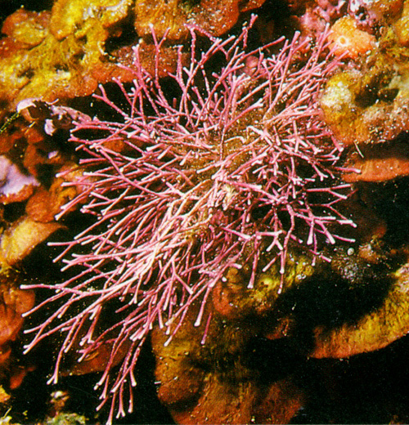
Amphiroa sp., Branched coralline algae
http://www.horta.uac.pt/species/Algae/Amphiroa_cryptarthrodia/Amphiroa_cryptarthrodia.htm

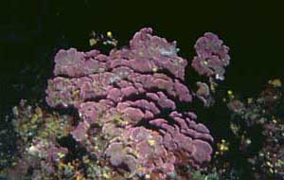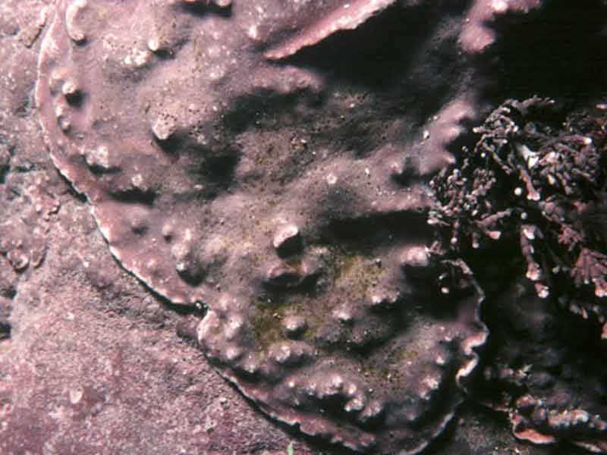
Lithophyllum sp., Encrusting coralline algae
http://www.marlin.ac.uk/baski/image_viewer.asp?images=litinc&topic=Species
http://www.np-mljet.hr/web%20galerija/podmorje/pages/podmorje22.htm

