Echinoderms

Class Ophiuroidea
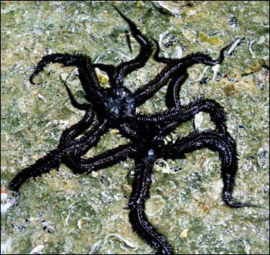
Ophiocoma aethiops
http://www.mcbi.org/GALLERY/pages/Ophiocoma.htm

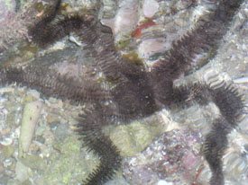
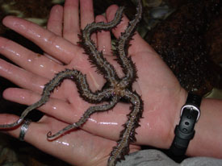
Ophiocoma aethiops, Giant black brittle star

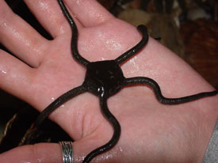
Ophioderma sp. Smooth brittle star
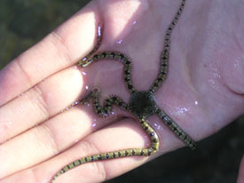
Ophionereis annulata, Ringed brittle star

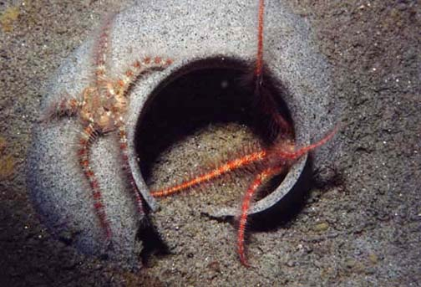
Ophiothrix spiculata, Barb-spined brittle star
http://www.divebums.com/FishID/Pages/brittle_star.html

Class Holothuroidea (sea cucumbers)
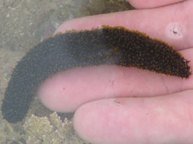
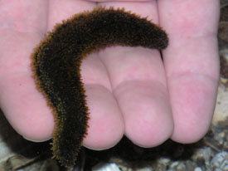
Sulfer cucumber, Holothuria lubrica
The sulfur sea cucumber is somewhat small
and soft compared to the other common sea
cucumbers in the Gulf.
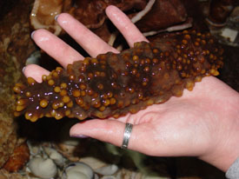
Isostichopus fuscus, Brown cucumber

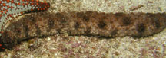
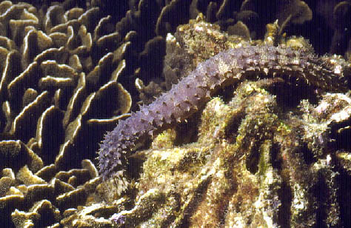
Holothuria impatiens, Bottle cucumber
http://www2.nrm.se/ev/dok/thaiechinod.html.en

Class Asteroidea (sea stars)
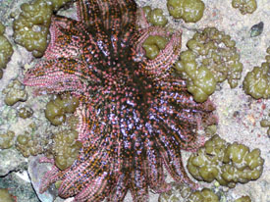
Heliaster kubinijii, Sun star

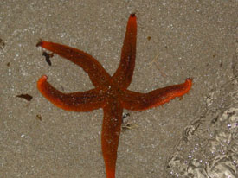
Class Echinoidea
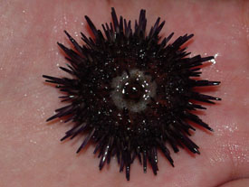
Echinometra vanbrunti, Common purple urchin *upside down

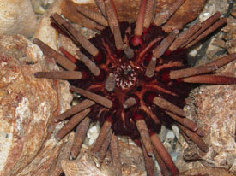
Eucidaris thouarsii, pencil urchin

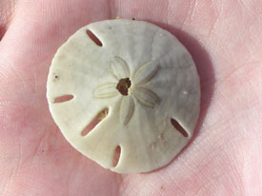
Mellita longifissa, Delicate sand dollar
Whitened or bleached-looking sand dollars are not alive; these are the endoskeletons of dead sand dollars.

All other photos from http://dtc.pima.edu/%7Enschmidt/gallery/gallery_index.htm

Echinaster tenuispina, Diurnal sea star

