Hierarchy of Life Activity

This activity relates to the organization or hierarchy of life. From molecules to social organisms, this activity will allow students to organize pictures of different organisms in a simple hierarchy.
The images are placed in the correct sequence below. This sequence shows an example of a simple hierarchy of life beginning with molecules and ending with social organisms. Two examples of each step along the helix are included. The helix should be printed up as well to give the students the construct needed to know organize all the images.

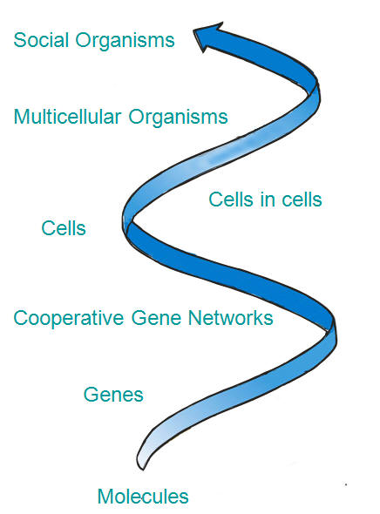
HIERARCHY OF LIFE ANSWER KEY

Water (molecule)
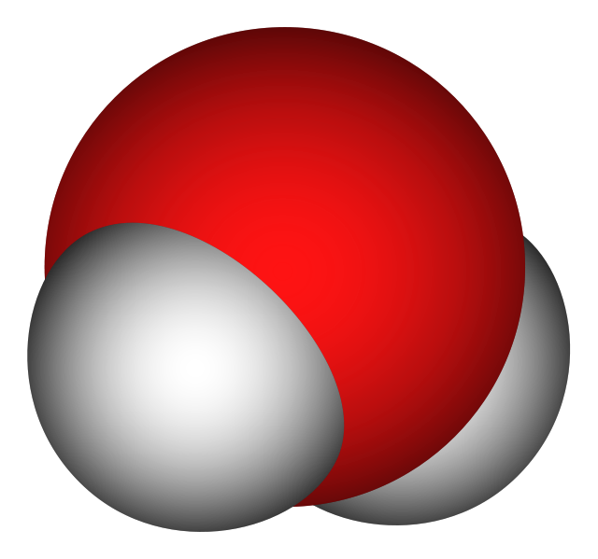
Caffeine (molecule)
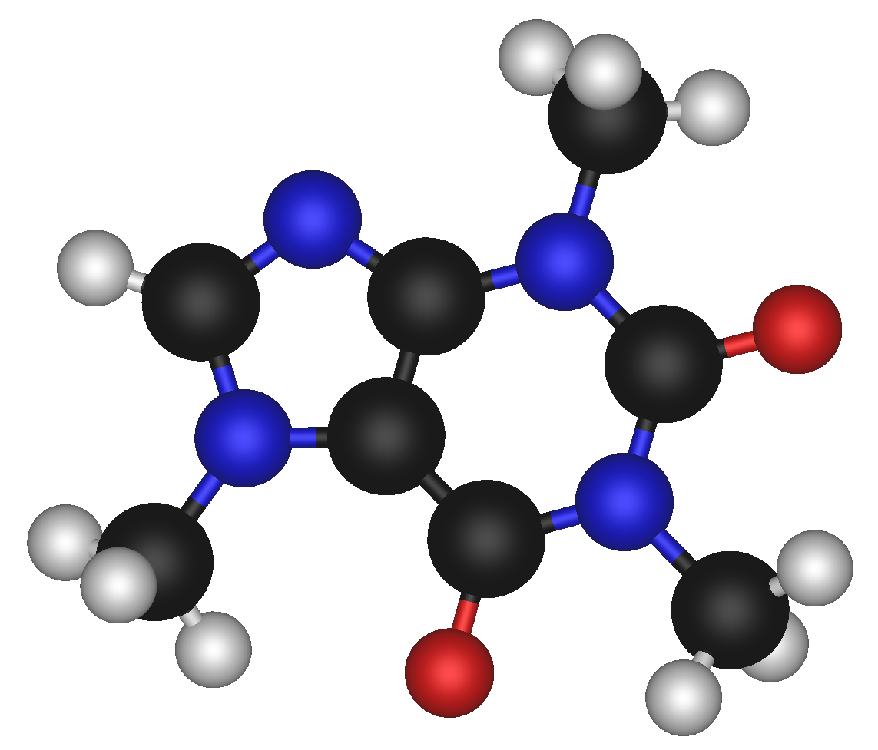
Gene
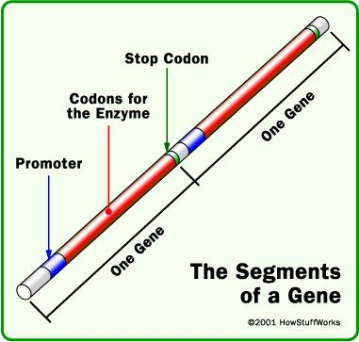
Gene network
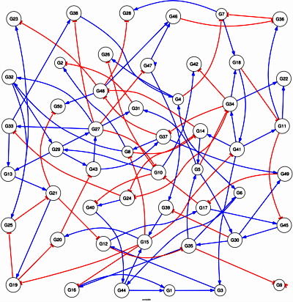
Bacteria (prokaryotic organisms / cell)
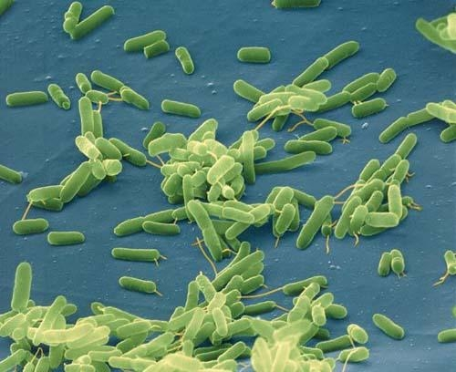
Yeast (eukaryotic organisms / cell)
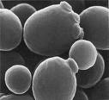
Eukaryotic cell (cells within cells, specialization)
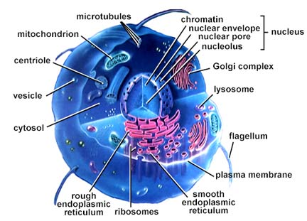
Volvox (multicellular organism)
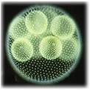
African Elephant (multicellular organism)
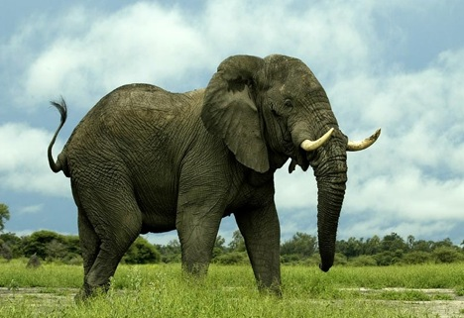Dart Frog (multicellular organism)
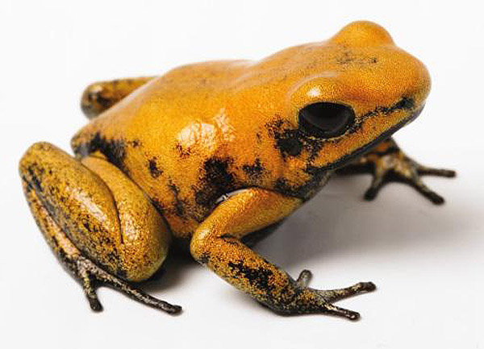
Bumble bees (social organism)
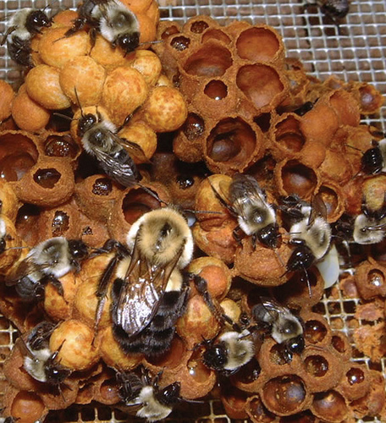
Termites (social organism)


